Piezoelectric Pressure Sensing Shoe Insole

Team 47: Gerald Kozel and Alan Lee

ECE 445 Project Proposal

TA: Kyle Michal

**1. Introduction**

**1.1 Objective**

Our goal is to create a device that can provide actionable health information to a health care provider without interfering with daily life. Specifically, we decided to focus on gathering quantitative foot pressure distribution data in a way that is clinically useful for evaluating various foot or posture pathologies. This data can be invaluable for avoiding extremity amputation for diabetics.

Over half of limb amputations (about 67 percent) in the United States are attributable to diabetes and related complications. The majority of limb amputations are performed on the lower extremities. Diabetic neuropathy and subsequent damage to sensory nerves in the feet contribute greatly to deformities and ulcers, thereby increasing the risk for amputations if left untreated. These statistics are alarming when compared with the CDC estimate that 30.3 million Americans currently have diabetes. From this data, we can draw that a cornerstone of diabetes self-management and education is foot care and continuous monitoring of patient foot physiologic symptoms.

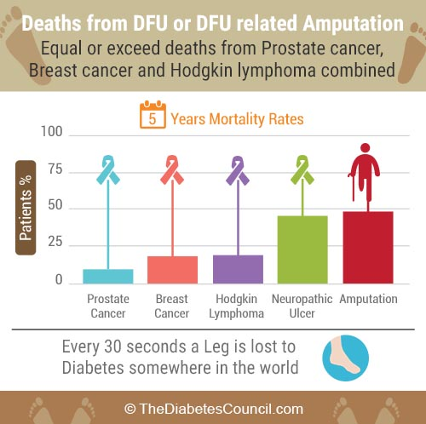

Figure 1 - Statistics on deaths from diabetes related amputation

We will achieve this by building a piezoelectric powered insole which is embedded with pressure sensors that is connected to a microcontroller. This microcontroller communicates via Bluetooth with a phone application which processes the data into a format which displays the user’s foot pressure distribution over a period of time. This can be a disruptive solution in monitoring whether neuropathic ulcers appear on the foot which is the primary reason for a foot amputation.

**1.2 Background**

Today, pressure mapping is mostly limited to lab analysis, kiosks, and existing commercial insoles. Both the kiosks and other insoles such as the DigitSole ([www.digitsole.com](http://www.digitsole.com)) provide pressure distribution data but does not facilitate the clinical application of said data. Rather, these focus on selling orthopedic insoles or providing runners with feedback in their techniques. TekScan, a producer of foot pressure sensing devices, offers a similar insole device called F-Scan. This solution is quoted at a price of $6,995 plus $35 per insole [1]. This is much more expensive than our planned solution, allowing us to sell the device to a much larger base of consumers for personal use.

**1.3 High Level Requirements**

1. Sensors feed a continuous stream of dynamic active foot pressure data and display it on a mobile app.
2. Insole should be able to run from full charge for at least 8 hours in normal operation (without considering piezoelectric charging capabilities).
3. Piezoelectric should offer significant energy savings (5-10%).

**2. Design**

**2.1 Block Diagram & Physical Design**

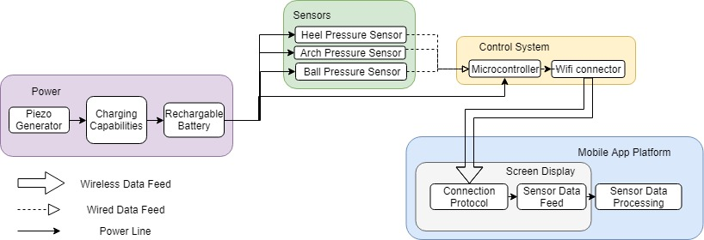

Figure 2 - Block diagram of design

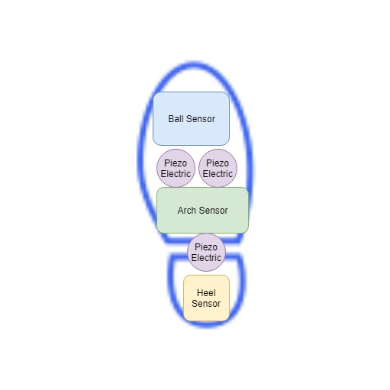

Figure 3 - Physical layout of insole

**2.2 Functional Overview**

There are four major modules in our planned physical design for a device. First is power, which includes our lithium ion battery and piezoelectric sensors. These connect to each other to enable charging capabilities as the user walks. This module primarily provides power to our sensor block where three pressure sensors are aligned on the sole, arch, and ball of the foot. Both the sensor block and the power block connect to our control system block, which includes a microcontroller and Bluetooth transceiver/antenna for receiving and sending the data to the app. Our app takes the sensor data and processes it into a feed for display on the screen.

**2.3 Requirements and Verifications**

**2.3.1 Power Supply**

*Piezoelectric Sensors*

These Sensors will provide supplemental power to charge the battery in use from the user stepping on them. This solves high level requirement 3.

|  |  |
| --- | --- |
| Requirement | Verification |
| * Must provide total 8-10 mA between 3.3-4V during normal walking operation. | 1. Measure the open‐circuit voltage with a multimeter, ensuring that it is in the 4V to 3.3V range. 2. Ensure that the current through the load is within 8-10 mA using a multimeter. |

*Charging Capabilities*

This module handles both typical charging operation along with integrating the energy generated from the piezoelectric sensor.  This solves high level requirement 3.

|  |  |
| --- | --- |
| Requirement | Verification |
| * Must convert AC to DC (bridge rectifier) and utilize a capacitor to store 8 hours of charge. | 1. Measure the current with a multimeter and ensure that the signal is of AC type 2. Test if the battery contains 16588.8 joules. (0.576 watts * 8 3. * 60 mins/hr. * 60 sec/min)  by having a power consumption rate of 1000 joules/s on the battery and seeing if the battery can last 16.5s . |

*Rechargeable Li-ion Battery*

Our battery will operate at 3.3-4.0V and will power the majority of our design.  This solves high level requirement 2.

|  |  |
| --- | --- |
| Requirement | Verification |
| * Must store enough charge to provide 160mA +-10mA at 3.3-4.0V for 8 hours without factoring in the contribution from the piezoelectric. | 1. Measure the open‐circuit voltage with a multimeter, ensuring that it is in the 4V to 3.3V range. 2. Ensure that the current through the load is within 160mA +- 10mA using a multimeter. 3. Test if the battery contains 16588.8 joules. (0.576 watts * 8 hrs. * 60 mins/hr. * 60 sec/min)  by having a power consumption rate of 1000 joules/s on the battery and seeing if the battery can last 16.5s . |

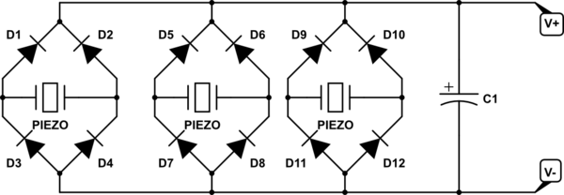

Figure 3 - example diagram for our piezoelectric and their associated capabilities

**2.3.2 Sensors**

*Heel, Arch, and Ball Pressure Sensors*

These pressure sensors will dynamically feed its foot pressure data to the mobile app at various parts of the foot. This solves high level requirement 1. Below we calculate our pressure sensor threshold criteria:

* + Threshold calculation: F = Mass * acceleration = Pascal’s * Area, ~950 newton’s
  + 95kg * 9.8 m/s^2 = 0.01 m^2 * Pascal’s.  Pascal’s = 95000 = 95 kPascals

|  |  |
| --- | --- |
| Requirement | Verification |
| * Has a power consumption rate of 0.576 watts. (P = IV = 0.16A * 3.6v) * Must be able to sense pressure up to 95k pascals | 1. While operating the sensors, measure with a multimeter the current and volts for 0.16A and 3.6v. 2. Step on pressure sensor to see if the data is received correctly up to 95k pascals. |

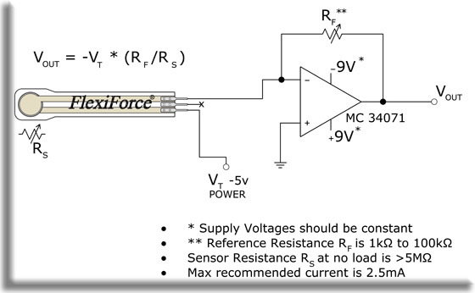

Figure 4 - layout for single pressure sensor diagram

**2.3.3 Control System**

*Microcontroller*

The microcontroller handles the three pressure sensor feeds. It will intake these inputs and utilize the Bluetooth transceiver to stream the data to the Mobile App Platform.  This solves high level requirement 1.

|  |  |
| --- | --- |
| Requirement | Verification |
| * Must be powered by a 3.6v +- 15%, 160mA +-10mA power supply for 8 hours * Must have sensor data input ports | 1. Must see the microcontroller turn on while measuring voltage input of 3.6v +- 15% and 160mA +-10mA readings 2. Test if the battery contains 16588.8 joules. (0.576 watts * 8 hrs. * 60 mins/hr. * 60 sec/min)  by having a power consumption rate of 1000 joules/s on the battery and seeing if the battery can last 16.5s while running microcontroller. 3. Verify microcontroller has sensor inputs |

*Bluetooth Transceiver*

The transceiver will be the component that allows the microcontroller to communicate with the mobile app platform. This solves high level requirement 1.

|  |  |
| --- | --- |
| Requirement | Verification |
| * Must be have microcontroller compatibility * Must operate on 800 Kbps bandwidth * Must operate on the 5-30 meter range, * Must operate with 200ms latency and bit rate of 2.1 mbps | 1. Verify microcontroller has Bluetooth capability 2. Verify device operation is not impacted within the range of 5-30m 3. Verify that data transfer of pressure sensors is lossless under 200ms latency and 800kbps bandwidth |

**2.3.4 Mobile App Platform**

The mobile app platform will serve as the main user interface for the patient/user. It will be comprised of a mobile app screen that will capture the sensor feeds and visualize it into an aggregated pressure map of the user’s foot.  This solves high level requirement 1.

|  |  |
| --- | --- |
| Requirement | Verification |
| * Must have Android OS compatibility * Must have a foot display for how pressure distribution * Must have Bluetooth connection to microcontroller on shoe | 1. Verify app can run on android device. 2. Verify app has foot pressure UI and dynamically changes with movement. 3. Verify connection is stable with device and phone. |

Simple app flowchart:

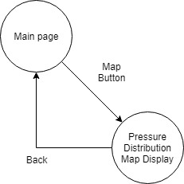

**2.6 Risk Analysis**

The Control System will pose the greatest challenge in the successful completion of this project. We must ensure that the microcontroller is compatible with the Bluetooth transceiver. The Bluetooth transceiver must have an adequate bandwidth and latency for a smooth stream of data from the connectors. It must also communicate to the mobile device which will be separated by a few feet (length of a person). The wiring of the microcontroller will also pose a challenge. Design on how it will be wired for power and sensor feed will be crucial to not obstruct the users walking while still having reliable wired connections.

Another module with a high amount of risk is our sole construction. Based on the way we set up the sensors it’s possible for wires and components to become loose as the entire rig is in consistent contact with the weight of a walking person. Additionally, our sensors will need calibration in order to receive usable data as

Our mobile app is the lowest risk of our modules. As long as our data and our communication protocol is sound developing the app to do some simple calculations on that data is relatively straightforward. We anticipate the least amount of problems working on this module of our design after putting sufficient work into our other modules.

**3. Cost**

**3.1 Parts**

|  |  |
| --- | --- |
| **Part** | **Cost (single)** |
| Piezoelectric sensors (Multicomp; ABT-441-RC) * 3 | **$3.39** |
| Lithium Ion Battery (SparkFun; PRT-13813) | **$9.95** |
| Microcontroller (Microchip; PIC32MX120F032B) | **$2.18** |
| Wireless Bluetooth transceiver (Microchip RN4870/71) | **$7.23** |
| Pressure Sensors (Interlink 406 FSR) * 3 | **$26.85** |
| Resistors, capacitors, op-amps, diodes (estimated cap) | **$5.00** |
| Foam Insoles (Target Up&Up) | **$0.99** |
| **TOTAL** | **$55.99** |

**3.2 Labor**

|  |  |  |  |
| --- | --- | --- | --- |
| **Name** | **Rate per Hour** | **Hours** | **Total Cost * 2.5** |
| Alan Lee | $40 | 14 hr/wk * 12 wk = 168 hrs | **$16800** |
| Gerald Kozel | $40 | 14 hr/wk * 12 wk = 168 hrs | **$16800** |
| **TOTAL** | | | **$33600** |

Grand total for our project comes out to be $49400 with both parts and labors.

**4. Schedule**

|  |  |
| --- | --- |
| Date | Deliverable |
| 2/23 | Design Document Design and review |
| 3/2 | Begin prototype |
| 3/9 | Finalize PCB design and parts ordering |
| 3/16 | Test design and parts, revise PCB |
| 3/23 | Spring break |
| 3/30 | Build PCB rev 2 and test |
| 4/6 | Finalize Product |
| 4/13 | Prep for demo |
| 4/20 | Final Demo |
| 4/27 | Final presentation |

**5. Ethics & Safety**

As with many engineering projects, there are a few possible safety hazards involved. Our lithium-ion battery rechargeable battery which powers the device has a possibility to explode. This usually occurs in the case of a short circuit, where all of the energy within the battery is released at once. Short circuits like this can happen when the plastic separator fails between the anode and cathode, allowing them to physically touch [2]. Over-charging and high temperatures must be avoided at all costs and must be tested for while building the charging module of our project. Other than proper testing we would ensure to get our batteries from a reputable supplier with a good track record for quality product. Additionally, we would provide proper insulation in the insole so that the battery is not subjected to extreme cold or heat.

Our project gathers and processes potential Protected Health Information (PHI), which is requires us to ensure confidentiality, integrity, and availability of said data [3]. We would not include diagnosis within the app to avoid violating #3 in the IEEE code of ethics by potentially misdiagnosing a user. Primarily the data would be in the hands of a medical doctor who could utilize it accurately.

References

[1] Open Lab, ‘Wearable Weight Sensing and Feedback Device’. [Online]. Available: <http://www.openlab.psu.edu/wp-content/uploads/2014/04/Garneau_Wearable_Weight_Sensing_and_Feedback.pdf>. [Accessed: 6-Feb-2019].

[2] Battery University, ‘Safety Concerns with Li-ion Battery’. [Online]. Available: <https://batteryuniversity.com/learn/article/safety_concerns_with_li_ion>. [Accessed 6-Feb-2019].

[3] HIPAA Journal, ‘What is Protected Health Information?’ [Online]. Available: <https://www.hipaajournal.com/what-is-protected-health-information/>. [Accessed: 6-Feb-2019].

[3] The Diabetes Council, ‘diabetes-and-amputation-everything-you-need-to-know-to-avoid-amputation’. [Online]. Available: <https://www.thediabetescouncil.com/diabetes-and-amputation-everything-you-need-to-know-to-avoid-amputation/>. [Accessed: 2/18/2019].